All Members Meeting
17th June 2024
Minutes
In Attendance:
Full Time Officers - Holly Roffe VP Education
Max Pike VP Societies
Emma Birch VP Sport
Enaya Nihal VP Welfare and Campaigns

Lay Trustees – Robert Pegg
Angella Hill Wilson

Student Trustees – Ben Abrahamson

Students Union Leadership Team – Philip Smith - CEO
Louise Marjoram - Membership Services Mark Crook - Finance

Chairperson - Holly Roffe
Agenda (as set out in the Memorandum and Articles of the Union)
- Ratification of minutes of the previous annual Student Members’ meeting ​
- Report of the Trustees on the Union’s activities ​
- Accounts of the Union to the Student Members ​
- Approving the list of affiliations of the Union ​
- Questions to the Trustees by the Student Members

- Ratification Of Minutes – There are no previous minutes for ratification.

- Report of the Trustees on the Union’s activities

Anna Taylor – President
- Bus survey to represent student experience of local bus services to service providers - over 900 responses.​
- Led on conversations with University colleagues about developing student consultation and collaboration in decision-making.​
- Represented and defended student interests in committees across the University's governance structures.​
- Led on the student contribution to the University's Academic Governance Review and review of professional services.​
- Worked with Projects & Campaigns to deliver another successful SHaG Fest!​
- Fed into ongoing work on restructuring our Byelaws.

Holly Roffe - VP Education
- Bi-weekly newsletter for course, department and faculty reps, to increase SU communication and engagement.​
- Worked with the University’s Disability Code of Practice team to ensure student co-creation is central to the training.​
- Alongside Vaish, collated a list of SU Education priorities, which were presented to a number of key stakeholders at the University.​
- Organised and helped lead an extended academic forum session, to workshop the new Education and Student Experience Strategy.​
- Worked with University colleagues to develop the new Access and Participation Plan, and began planning for the student submission.​
- Co-led a session on Inclusive Student Experience and Transitions at the "Ahead Together" conference.

Max Pike - VP Societies
- Revising and refreshing societies forum to make it somewhere that students can actively and regularly inform/impact decisions.​
- Welcome Week & Societies Fair: Everything from academic inductions to working the SU stands, and of course Societies Fair.​
- Societies Assembly to meet 2 execs from every society - and offer updates on what we’ve been up to, relevant changes, along with a Q&A. ​
- Finished the New Societies Application Process.​
- Rewrote the Student Activities Byelaws and began work on a compliance process to ensure societies are supported and treated fairly.​
- Allocated over £1000 of emergency support for societies.​
- Co-led on SHaG Fest, and kicked off planning for Exec Welcome, Welcome Week and Union Awards.

Vaishnavi Ravi - VP Postgraduate
- PG Fair was successful - had a good turnout.​
- PG assembly is now running, had the first assembly in term 1.​
- Cost of living workstreams have all started to meet now.​
- Ran two successful PG Connections events (Badminton and Arts & Crafts).​
- Represented postgraduates in the creation of the next education and student experience strategy.​
- Participated in the academic governance review to represent students.

Sophie Clake - VP Democracy & Development
- Liberation Conference: Planned a collaborative set of workshops, talks and discussions, for students to come together to discuss and learn about a variety of political issues affecting marginalised people.​
- Warwick Growers: Trying to increase small growing on campus, increase the size of our allotment space, and create a community-supported agriculture scheme.​
- Demilitarisation: Mapping out University relationships, speaking with relevant student groups, and liaising with SU officers and forums.​
- Began the process of establishing another allotment.​
- Confirmed the presence of a student swap shop on campus.​
- Began the process of bringing a policy on arms and the MoD to university council.

Enaya Nihal - VP Welfare & Campaigns
- 1,268 responses to the SU x Uni “Safer @ Warwick” survey - resulting in multiple measures to increase night-time safety.​
- Received the full £8.2k, applied for from the Warwick Innovation Fund, to start the (Free) Breakfast Club in Terms 2 and 3!​
- Relaunched the Women + Non-Binary Students Self-Defence Classes, training students with combat sports clubs.​
- Delivered the (Free) Breakfast Club offering to 350-500+ students twice a week with SU staff and volunteers.​
- Led the End Period Poverty campaign, supplying free pads and tampons to over 40 bathrooms on campus.​
- Allocated £7,000+ of the Project & Campaigns funds through Welfare Forum to societies and individual campaigns.

Emma Birch - VP Sports
- Successfully delivered Sports Fair - the event saw over 7,000 attendees, clubs have had more memberships than last year.​
- Granted £4,000 from the University Innovation Fund for my “Sportswear for all fund”.​
- Worked with Enaya and combat sports clubs to deliver self-defence classes for Women and students who identify as non-binary​
- Reduced Sports fees by 25% for the remainder of the year. The first-time sports fees have seen any decrease in the last 5+ years.​
- Ran and organised Varsity where we came away with our 34th win!​
- Began wider discussion of implementing a permanent reduced sports fee.​
- Ran Presidents Forum which had an attendance of over 75% of presidents.​
- Wrote and supported with creating the Student Activities operational documents.

- Accounts of the Union to the Student Members ​
- The Union produces annual consolidated group accounts (incorporating MSL and SUSW) annually.​
- These are prepared in line with the Charities Statement on Recommended Practice and in line with FRS102.​
- The report provides a Trustees Report together with a strategic report as well as the main financial statements and supporting notes.​
- The accounts are independently audited by RSM UK.​
- The WSU Board approved the accounts in January 2024 and these have now been filed with both Companies House and the Charity Commission​
- A full copy of the accounts can be found on the Warwick SU website at https://www.warwicksu.com/your-union/how-the-su-works/finances/22-23/

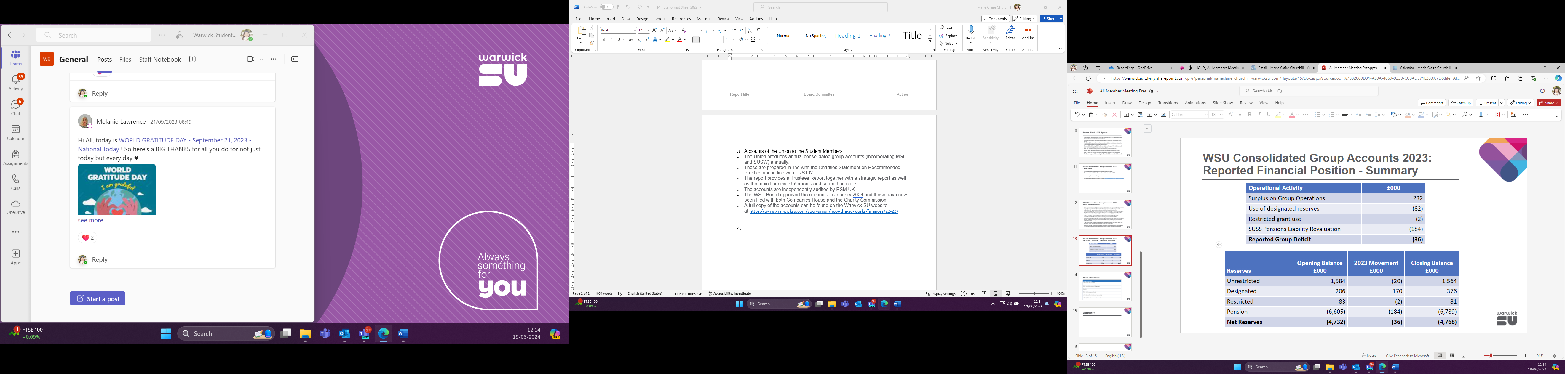

Additional points – The group reported a loss of £36,000. Our reserves position is guarded by the Board of Trustees reserves policy which is set at a target for unrestricted reserves of £775,000. At the end of July 2023 the reserves are at £1.564m.

The Board have further designated funds to support future development across the Union.

I accordance with regulations we are in compliance in filing the Students’ Union Accounts with Companies House.

- Approved the list of affiliations of the Union ​
- National Union Of Students (NUS)
- British Universities and Colleges Sport (BUCS)
- AdviceUK
- Child Poverty Action Group (CPAG)
- National Council of Voluntary Organisations (NCVO)
- UK Council for International Student Affairs (UKCISA)

- Questions to the Trustees by the Student Members
Any questions can be raised by contacting Louise Marjoram at Louise.marjoram@warwicksu.com

