Summer Elections General Candidate Guide

Thank you for wishing to be a University of Warwick Students’ Union Representative and running in the Summer Elections! If you would like more details about the elections, go to Nominations (warwicksu.com)

If you have any questions about the elections, please contact studentvoice@warwicksu.com

Contents

- 7 steps to becoming an representative.
- Positions available
- Key dates
- Nominating yourself
- Manifesto
- How to campaign
- Candidate welfare
- Complaints & campaigning rules & regulations
- Voting, results & checklist

7 Steps to stand in an election

- Decide your role – Check out the roles at warwicksu.com/elections, speak to friends, the current representatives, or the SU staff to see which one is right for you!

- Nominate yourself & submit manifesto - Follow the online instructions to nominate & submit your manifesto before the deadline prescribed.

- Gain the knowledge - Find out about the rules, timeline and advice on the SU website here Rules & Guidance (warwicksu.com) and below.

- Write your manifesto - Who are you, why are you running, and what will you do if elected? Remember to upload your manifesto by the prescribed deadline. Manifesto advice can be found below and further details here Manifesto Guide (warwicksu.com).

- Plan your campaign – Utilise the resources issued by the student voice team alongside talking to your campaign manager to formulate how you want your campaign to look and what does success look like for you as a individual candidate. Please note:those nominated for Full-Time Officer Positions are eligible to receive a reimbursed campaign budget of £50.00, and those nominating themselves for forum positions are eligible for a reimbursed campaign budget of £0.00 this Summer Elections

- Begin your election campaign – You can start campaigning once voting opens on __26th May 9am___ until it closes on 30th May 12 midday.

- Await the results and big decision! – once voting closes, be in SUHQ with your campaign manager if you are running for a full-time officer position to await the results. Otherwise if you are running for a forum member position please keep an eye out on the Warwick SU website where the results will be presented to the student body.

Positions Available

Full Time/Part time Officers:
Vice President for Sports [FTO Position]

Forum Member Positions:
- Operations Forum Member (open place) - 7 Positions
- Societies Forum Member (open place) - 7 Positions
- Sports Forum Member (open place) - 7 Positions
- Steering Group Member (open place) - 7 Positions
- Sustainability Forum Member (open place) - 7 Positions
- Welfare Forum Member (open place) - 7 Positions
Academic Representation:
- Academic Representation: Arts faculty rep (Open Place) - 2 positions
- Academic Representation: Arts faculty rep (PGR)
- Academic Representation: Arts faculty rep (PGT)
- Academic Representation: SEM Faculty rep (Open Place) - 2 Positions
- Academic Representation: SEM Faculty rep (PGR)
- Academic Representation: SEM faculty rep (PGT)
- Academic Representation: Social Sciences faculty rep (Open Place) - 2 Positions
- Academic Representation: Social Sciences faculty rep (PGR)
- Academic Representation: Social Sciences faculty rep (PGT)

Nominating yourself

How?
Nominations take place online at www.warwicksu.com/elections/nominate-yourself. You can follow the on-screen instructions to nominate! If you have any difficulties, email studentvoice@warwicksu.com with screenshots of the problem.

Manifesto

A manifesto is your statement to students explaining why you believe you are the best candidate, your aims and promises and why students should vote for you. Your manifesto can be submitted as an imageand include colour/pictures but must include plain text version of your manifesto after the image for accessibility purposes. This will be made available online for students to read. It is important to do a manifesto as it helps convince students to vote for you and give you priorities for the year ahead. It also sets students’ expectation of what you hope to achieve.

Contents in a manifesto
- What do you want students to know about you? (relevant experience, what you believe, what you want to change, your ideas)
- Stick to a few key points/priorities!
- Do not just rely on what you think you know – speak to your friends, course mates and the wider student body about what they care about
- When thinking about what to pledge to students:
  - Be realistic and be precise: you are only elected for 1 year to implement these promises, so you want to make sure they are achievable and believable.
  - Look at the SU strategic plan and current policies on the Student Voice pages to help you.
- Be SMART
  - SPECIFIC: clear about the goal/promise/priority
  - MEASURABLE: is there a way to measure whether the goal/promise has been successful?
  - ACHIEVABLE: could it happen? Outline when and what success looks like
  - RELEVANT: are students bothered?
  - TIME-BOUND: when will it happen?
- Proofread and get others in your campaigning team to read it through.
- Focus on yourself not others.
- Don’t feel the need to write loads – quality over quantity.
- Do not forget to add your social media profiles to your manifesto.

Designing your manifesto
- Your manifesto should be easy to read, clear and have text colours that do not contrast with the background.
- You can use colour contrast checkers online to check your information can be easily read, such as https://contrastchecker.com/
- Make sure each section is clearly defined so students can identify things quickly and easily when skim reading.
- Use Photoshop, Publisher or Canva and save your design as a picture so that you can upload it easily.
- Also see the website on structuring your manifesto - https://www.warwicksu.com/student-voice/elections/rules-guidance/manifesto-guide/

Structuring your manifesto
Typically, manifestos will have the following sections in the following order:

- Your name, picture, plus any slogan you are using.
- Who you are, why you are running and your experience.
- A list of your top priorities and why
- How you will tackle these priorities (short bullet points work best)
- Your social media links.
- The voting links.
- Your plain text manifestoes.
- Short, snappy and to the point works best.
- Focus on no more than 5 priorities.

Uploading your manifesto
Remember this is the online manifesto which any Union website user will be able to view, and importantly, can be viewed at the point of voting. You can view more about writing a manifesto here - Manifesto Guide (warwicksu.com)

- You upload your manifesto online in which can be amended until the deadline given by the student voice team.
- You can upload pictures, images, and graphics in your manifesto, but please note:
You must upload a plain text version of your manifesto as well. Please do not bold or underline the text in this manifesto or use coloured text or pictures. Do not use excessive capital letters when writing this manifesto. It must have the same word content as your original manifesto. Manifestos will not be uploaded if there is no plain text manifesto provided. An example of a point from an appropriate plain text manifesto is as follows:
‘I promise to turn the democracy hamster into a democracy gorilla and make a new gorilla suit for the DDO to wear at election time.’

See Screenshots here on how to upload step-by-step
- Once you have successfully nominated yourself and received email confirmation of your candidacy, click the upload manifesto button back where your nomination was confirmed (picture below)
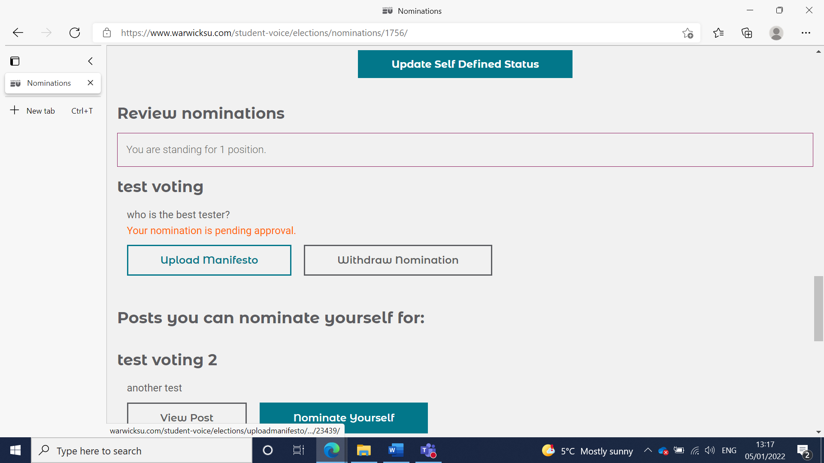
- You can then upload a profile picture to your candidacy and nomination where it says ‘Profile Picture’ à ‘choose file’ à ‘upload’– do ensure it is a JPEG and doesn’t go over the limit. If it does, try to reduce the quality and size. (picture below)
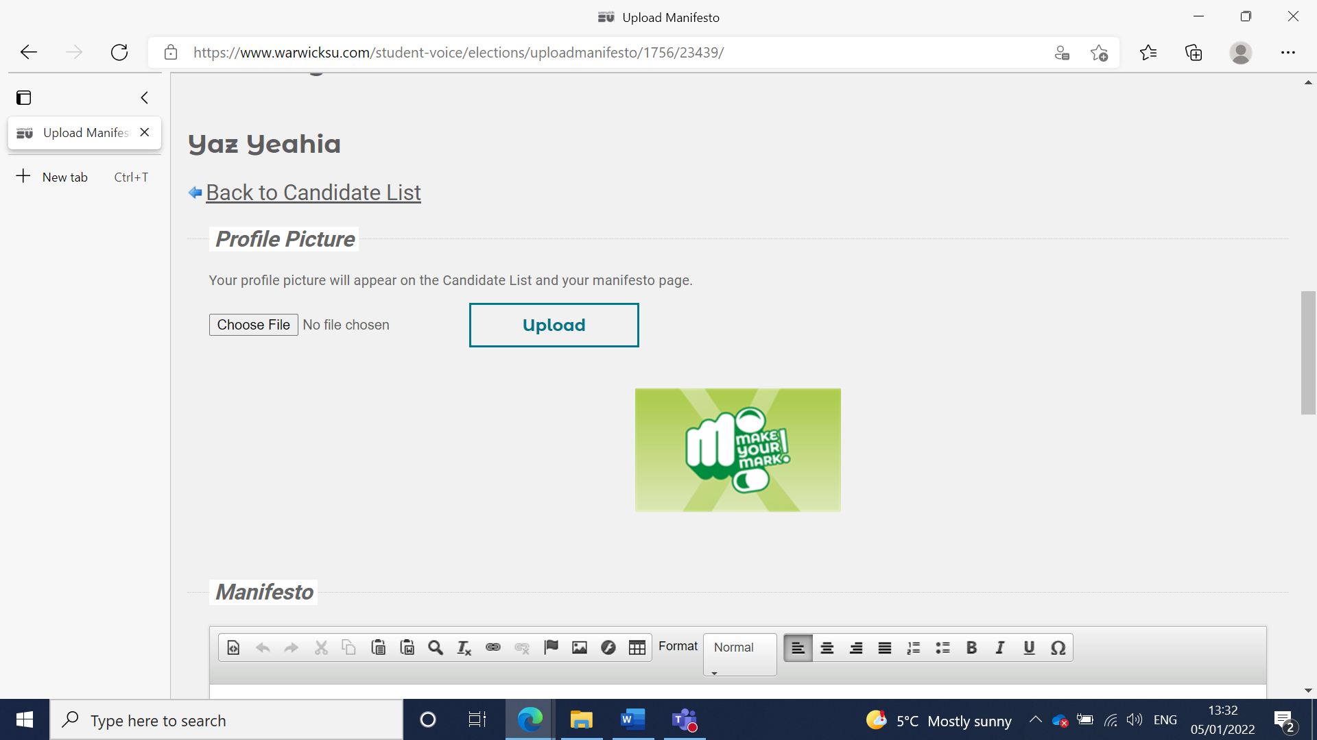
- Once profile picture has been uploaded, below you can upload a digital manifesto below. Click the image curser on the top of the manifesto section
Digital Manifesto Image cursor
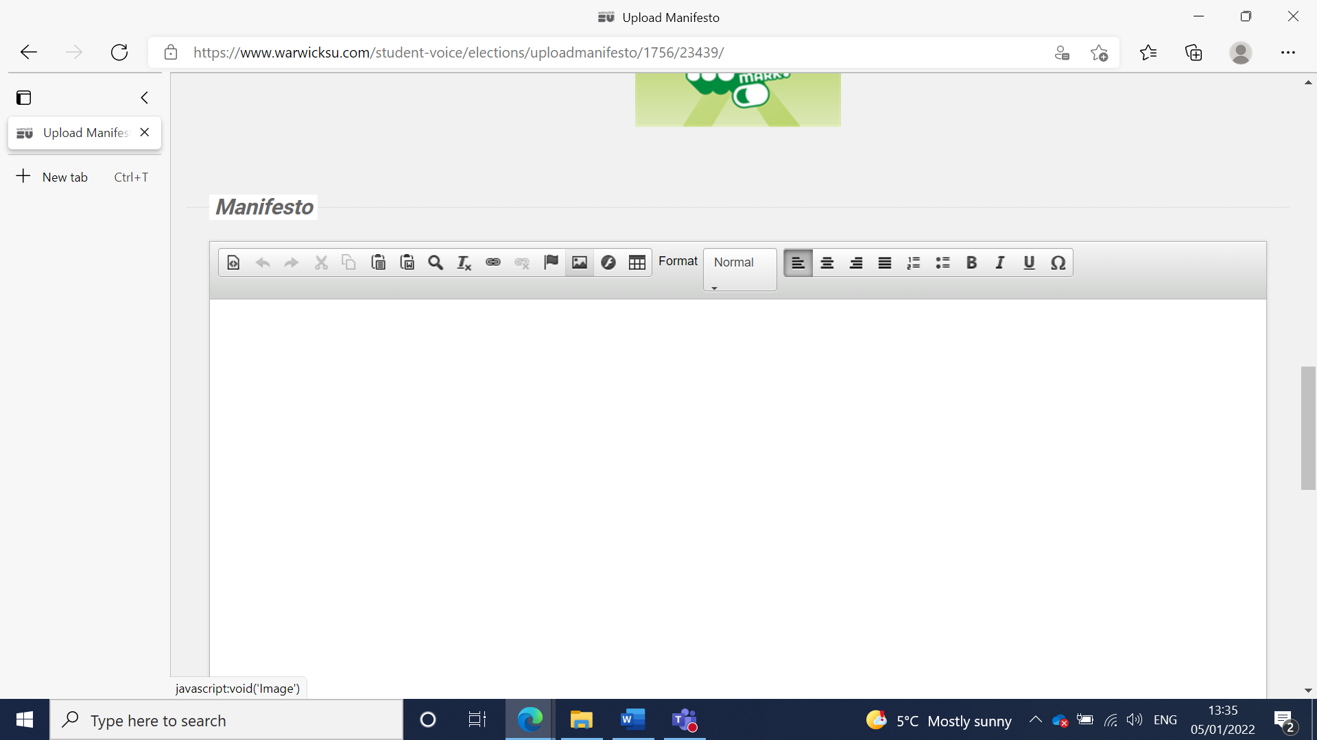
- Click browse server to upload the picture
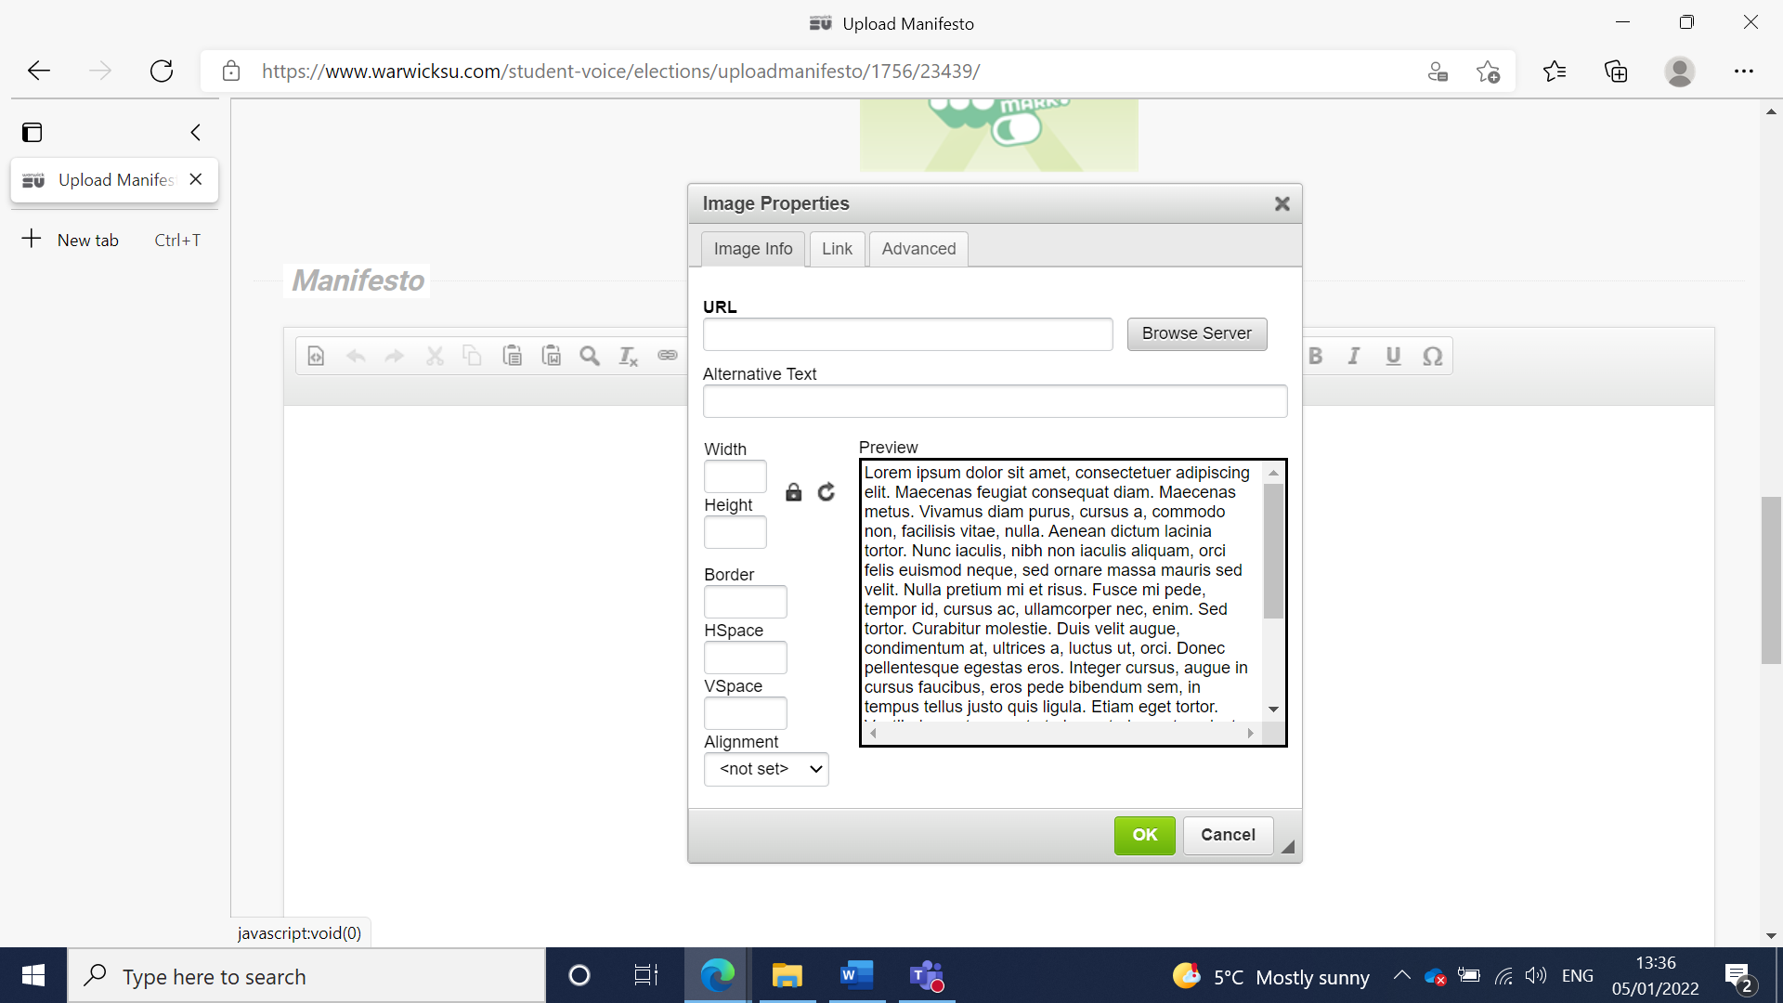
- If the picture is a bit stretched, go to advanced and under style input the following ‘object: fit-contain’ – in order to keep your picture from being too stretched.
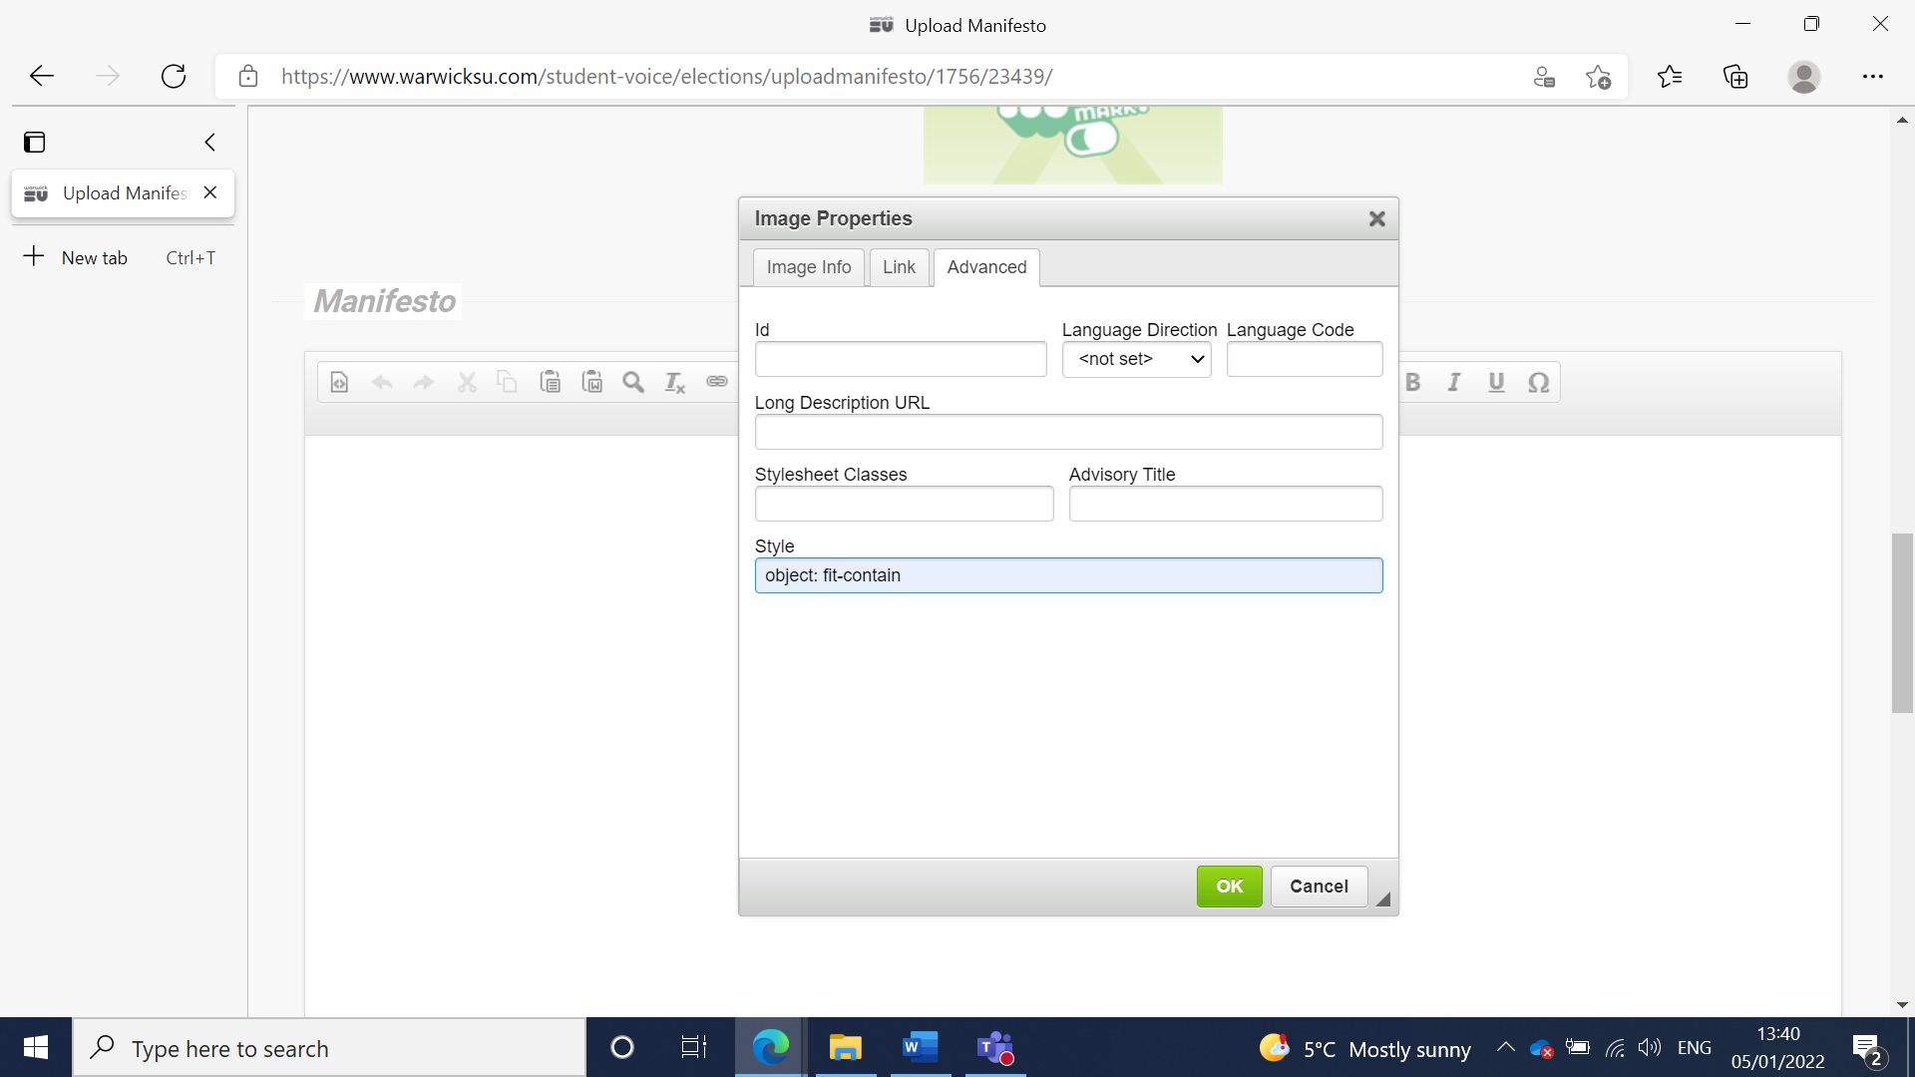
- Once done, underneath your manifesto do ensure you write it up as plain text and have thoroughly read through our accessible manifestos doc here - Rules & Guidance (warwicksu.com) then save and you have completed your manifesto!

In the event you have decided to do a video and want to have it uploaded on your manifesto page that’s fine. All you will need to do is follow the below instructions
- Click the YouTube symbol on the top of the Manifesto section
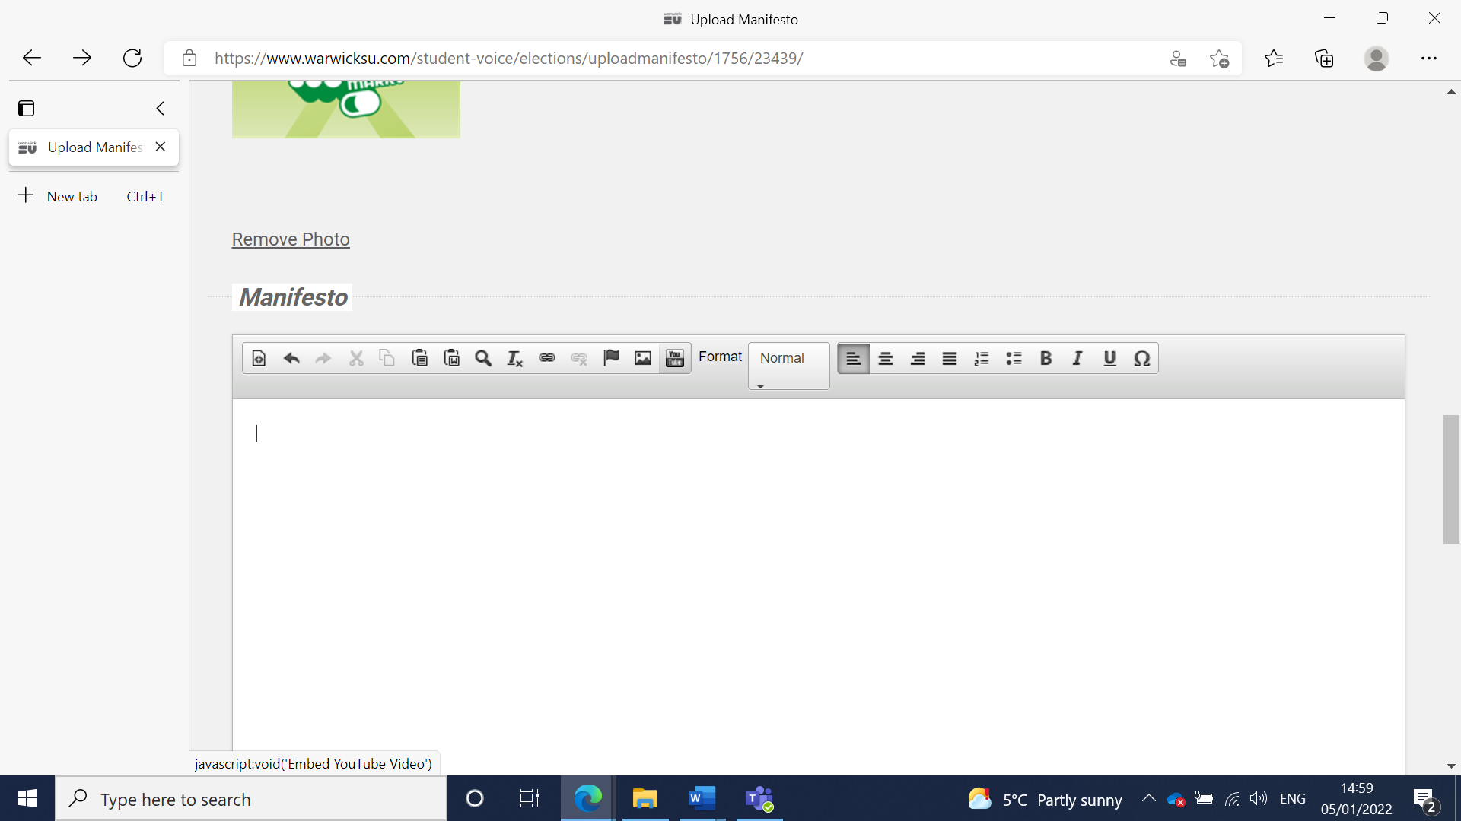
YouTube Image cursor
- Once selected, embed the YouTube link under the YouTube video URL link (or code) and choose from the other options below the field. (If you want to autoplay etc) click save and you are good to go!
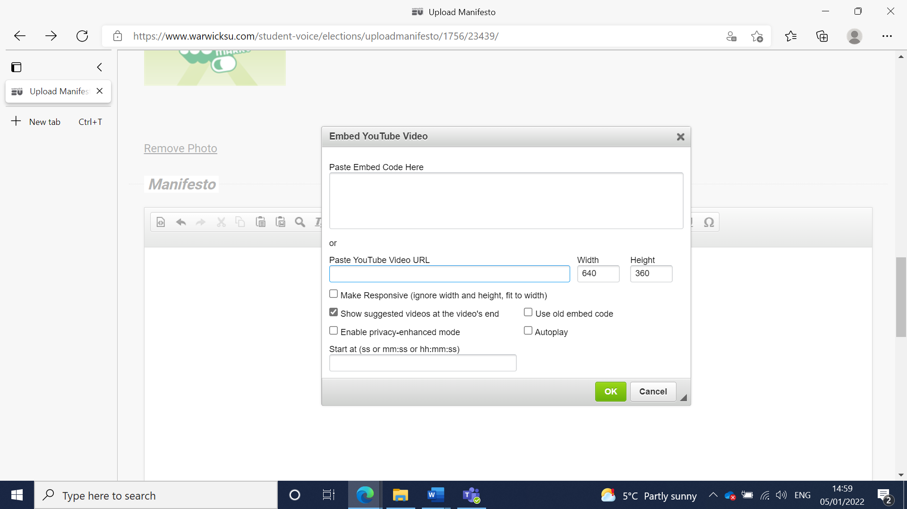
- Ensure you include YouTube captions for your video and underneath the video as plain text make note that there is a YouTube video to select and view.
To find out more information on delivering an accessible manifestos and social media guides see the ‘Elections Rules & Resources’ tab here Rules & Guidance (warwicksu.com)
Campaign material printed should be done in the first instance at reception where they will print leaflets or other promotional material. Keep the records of receipts and email your printing requests to print@warwicksu.com.

How to campaign

Campaigning is the time you spend speaking with students to encourage them to vote for you, explaining why you are the best candidate online and in person. Your image and publicity are key to winning any election!

Do speak with the Student Voice Team about how they can ensure campaigning is accessible for you.

Campaign Theme
Have a theme running through your campaign that makes your candidacy memorable. Themes can be linked to names or a character that is relatable to Warwick students and have included funny puns on people’s names or a focus on key ideas.

Campaign Slogan
Many candidates choose a catchy, memorable phrase across their campaign to attract students, give a feel of their campaign and set them apart from other candidates. Tips for a strong slogan:
- Research slogans from past elections
- Link it to your name to help students remember who you are.
- Make it short, snappy, and original!
- Link it to something memorable.

What does a typical campaign at Warwick look like?
Candidates gather a campaign team. See whether any of your friends would be interested in helping, how much time they could commit and what sort of thing they would be interested in helping with.
Draw up a campaign plan – who is doing what when? Look at the online lecture & seminar groups you have and populated open groups for everyone to use on social media.
Make sure your campaign team are behaving appropriately – they are representing you (see rules and regulations on campaigning)
Social media also plays a big part in campaigning at Warwick (getting even bigger every year!) – create your own Facebook like page or event, a twitter hashtag, or a video to let students know about you and your ideas.

If conducting lecture / seminar shout-outs online:
- Always ask the permission of the lecturer
- Keep it less than a minute.
- Begin and end with your name and the position you are running for
- 2-3 of your manifestos promises.
- Tailor it to your audience – what will the students in that lecture care about?

You must register your campaigns team using the google doc below. They are responsible for your campaign and if they are to be in breach of any of our rules and regulations, they are at the adjudication of your own candidacy.

You should register your campaigns manager as well as other members on your campaigns team. They can only be Warwick students.

For any campaign manager, they can only manage one candidacy and not multiple and should be mentioned and named when requested by the student voice team to ensure they too agree to follow the rules in benefit of the democratic values closely followed during elections.

Expenses and Campaign Materials

Please note – we are reimbursing costs to campaigns for Summer Elections. See below up to how much you are eligible for. If you wish to distribute campaign materials you can, but follow the advice below.

Full-Time Officer Candidates can reimburse a total of up to £50.00 per candidate.

Forum Members and Academic Representatives can reimburse a total of up to £0.00 per candidate.

Any of those that are part of a joint ticket (two students nominating as one candidate) are only eligible for the costs of one candidate.

You cannot overspend on this budget and will be disqualified if you are found to have overspent. This is to make the election affordable and fair for all candidates.

Items will be able to be reclaimed at a cost. If you are using things you already owned, apply a reasonable a cost to the item for you to declare and reclaim, we will ensure that it matches and will make final call on that price.

You can download the form for reimbursements here – do ensure you keep receipts to keep track of your expenses. The deadline for reimbursements will be allocated and communicated by the student voice team and is final.

Items/Activities you cannot use
- You must not use any private vehicle to promote your campaign, or have any publicity posted on or within a vehicle so that it is on display
- You must not spend money on alcohol, drugs or tobacco to promote your campaign.

Distributing publicity
- Do not place publicity in any areas of the University not stated details to be found out in our Candidate briefing sessions.(
- The Students’ Union may be putting posters up of our own election materials across campus in various popular locations. Do not remove these materials or poster over them. They will be promoting the elections and encouraging people to get voting!
- Do not cover up another candidate’s publicity.
- Do not remove another candidate’s publicity.
- Do not deface another candidate’s publicity.

Candidate Welfare

- Take care of yourself and your team – eating, drinking, taking time off, speaking to friends, visiting the Student Voice Team.
- Do not force yourself to do something you do not want to do.
- The same methods do not suit everyone, everyone has their own style, and you do not have to do what other candidates are doing.
- If you have an issue, contact the Student Voice Team, or speak to the advice centre, we are here to help you!

Complaints

Sadly, some people do try to do something that is against the rules. Inevitably when this happens, they get caught out. Sometimes rule breaking is deliberate and sometimes it is accidental. There is, however, no distinction; if you break the rules, we will take action against you. Campaigning should be in the spirit of fair play.

Negative campaigning is not acceptable. Criticising policies is allowed, but not people. Though you should always endeavour to keep the campaign positive. What is great about your manifesto rather than why someone else’s is bad. If a candidate breaks any of the rules that have been communicated, sanctions will be taken.

When a complaint is submitted, the Adjudication Panel will meet as soon as possible to review the complaint. They will make a ruling on the complaint which will be communicated to the candidate it refers to, and then sent to all candidates and published on the website. If in doubt, ask the Student Voice Team before you act. The deadline for complaints will be allocated and communicated on behalf of the Student Voice team.

How to make a complaint?
- Log in to warwicksu.com and head to student voice à elections à elections complaint à log a complaint
- Fill in the form to submit a complaint with additional evidences and requirements
- Follow our rules and regulations on complaints
- Wait for acknowledgment from Student Voice Team about your submission
- If the Deputy Returning Officer deems it appropriate, they will conduct an investigation in to the complaint and if it holds then appropriate sanctions will be applied in line with our rules and regs
- The decision will be uploaded on our complaints log and will be informed to members

Some advice about complaining.
We will not act in the event of complaints that have no basis. For example, if you come to us with the complaint “lots of my posters have been removed, but none of candidate X’s have – it must be them doing it”, this is an accusation with no grounds, and we are unlikely to be able to do anything but dismiss the complaint. If you come to us and say “at 3:30pm on Monday I saw a member of candidate X’s campaign team remove one of my posters”, along with a picture, we may be able to act.

Do not complain merely for the sake of complaining or to try to get someone into trouble so you can benefit. Negative campaigning can also take the form of excessive complaining and trying to trip other candidates up, and if you are found to be doing this action will be taken against you. If somebody does something wrong report it and we will act, but above all focus on why you are the best and what is good about you and your campaign, not on somebody else’s.

Campaigning Rules and Regulations

Candidate Behaviour:

- Campaigning commences from the allocated and communicated date set by the student voice team.
- Your campaign materials should be accessible in the English Language.
- You are responsible for the actions of anyone helping with your campaign. If they break the rules on your behalf, it is you that will be penalised.
- No negative campaigning: Negative campaigning can take the form of smear campaigns, comments about other candidates that have no basis, excessive and malicious complaints about candidates, and a campaign focusing on other candidates rather than concentrating on gaining votes for your own campaign. This extends to digital campaigning as well as physical. This sort of behaviour is unacceptable and discredits yourself more than the other candidates.
- Do not defame the character of any other candidate. You may criticise another candidate’s policies, but attacks must NEVER be of a personal nature. Consistent comments of this nature will be sanctioned.
Publicity & Social Media:

- Your publicity must not violate the Students’ Union’s policies or governing documents (visit Student Voice in SUHQ for further information).
- Social media: you must abide by the SU and University code of conduct when posting to social media – the rules regarding candidate behaviour apply to social media as well. Guidance will be on the website for SU Clubs and Societies regarding allowing candidates to post in groups.
- Candidates can post in any groups or chats on social media that allow them to post in.
- Posting on social media and groups chats will be subject to the same rules as physical campaigning therefore you must not violate the SU or University Code of Conduct or SU Governing Documents
- Candidates can post on SU social media posts but not repeatedly.
- Social Media pages that have previously been used to run campaigns cannot be used again as this will create a disadvantage for students running for their first time in the elections.
- You can create a private page now but cannot be made public until campaigning starts.
- No publicity or campaigning is allowed near the SU Student Voice Team and Candidates will be aware of where they can campaign.

Slates (A slate is a group of candidates running together) & Endorsements.
- Slates (running together on the same platform of ideas, e.g., the same manifesto) are not allowed.
  - This means candidates are not allowed to pool their resources, appear in each other’s publicity, have identical or almost identical publicity / manifesto content, or endorse other candidates.

- Societies and Clubs cannot endorse candidates.
- SU representatives, & Warwick SU staff cannot endorse candidates. This includes Faculty and Departmental Reps along with any other Elected Leaders.
- Warwick staff cannot endorse candidates, it is reasonable to have “likes” on social media from people outside the SU (e.g – friends & family), but they can’t be solicited.
- If you are already a Union Officer, it is important that you do not use ANY facilities which your position gives you special access to for your campaign.
- If you work for the Students’ Union or University, it is important that you do not use your position(s) or any of the privileges your position(s) gives you for your campaign.
- You will be responsible for the cost of cleaning or repair of any damage to Students’ Union or University property caused because of your campaign.
- You cannot campaign inside the library or any study space. This includes leaving any campaign materials in these spaces, e.g: leaflets, flyers etc.
- External campaigners are not allowed on campus. Only SU members can form part of you campaign teams and campaign on your behalf. It is reasonable to have “likes” on social media from people outside the SU (e.g – friends & family), but they cannot be solicited.
- People can only stand for 1 position out of FTOs and PTOs
- You are unable to nominate as a joint ticket (more than one person per candidate)
- Bylaws can be found here - CombinedByelawsJan25PostBoard-FINAL-upload.pdf

Voting and Results

- Voting will take place online within a timeframe allocated and communicated to candidates by the student voice team. Beginning on __26th May 9 am__ and closing __30th May 9 am__.
- The results count will take place immediately after this, and candidates will be informed of the provisional result via email once they have been publicly announced on the SU Website.
- The results are only final after the complaints deadline has passed.
- Those successful will receive an email congratulating them afterwards, and ask for their attendance to a meet and greet scheduled by the Student Voice Team.

Checklist

- Nominate yourself online at: www.warwicksu.com/elections (don’t forget to self-define)
- Attend the Compulsory Candidate Briefings
- Begin Planning your campaign – gather your team, consider how you will market yourself, attend campaigning training
- Register your campaigns team – you can email the Student Voice team studentvoice@warwicksu.com.
- Upload your online manifesto before the deadline. (Make sure you include plain text)
- Begin campaigning, same time as voting opens on ___26th May 9am___.
- Take time to recover – book something to do after voting closes on __30th May 9am____.
- Fill in our candidate evaluation sessions to give feedback on your elections experience
- If you have any problems, please email us at studentvoice@warwicksu.com

GOOD LUCK TO ALL CANDIDATES, CAMPAIGN TEAMS AND ENJOY THE EXPERIENCE!

