Proof of elections – Warwick Friends Society (Example)
Format/Process
Voting was in person at an AGM called on 20th February 2023. Candidates for each position were invited to nominate themselves by emailing the Returning Officer about the position that they wished to run for. This process was outlined in the election announcement which was sent out as an all members’ email on the 9th February 2023. Voting for in-person attendees was by paper ballot, which was collected and counted by the Returning Officer while online attendees voted by email. Members were asked to submit their student ID numbers alongside their ballot/email votes to double check society membership. See announcement email copied in below:
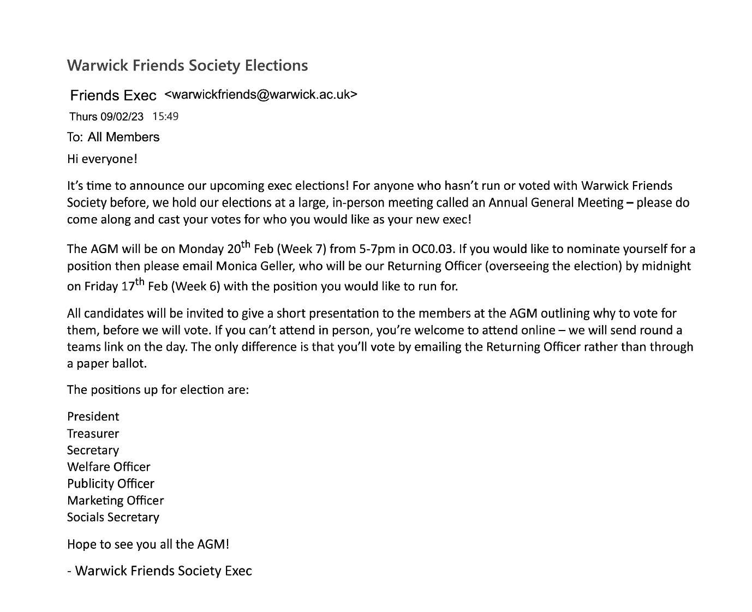
Nomination windows must be at least 7 days long.
All members must be given at least 14 days notice to vote – this might be a week’s notice for an in-person vote, or alternatively announcing a 7-day online voting window.
Online votes must be open for at least 48 hours.
Timeline
Elections announced to all members: 9th February 2023
Nominations opened: 9th February 2023
Nominations closed: 11:59pm, 16th February 2023
Voting: in person/on teams, 5-7pm 23th February 2023

Positions and Successful Candidates
President – Rachel Greene
Treasurer – Ross Geller
Secretary – Phoebe Buffay
Welfare Officer – Phoebe Buffay
Publicity Officer – Chandler Bing
Marketing Officer – R.O.N.
Socials Secretary – Joey Tribbiani

Minutes of the Meeting
The Returning Officer should be someone without vested interest in the election – this could be a trusted outgoing exec member, or alternatively one of the SU Student Voice advisors, or the VP for Societies.
Attendees: 28 of 56 members in attendance
Returning Officer: Monica Geller (MG - outgoing Secretary)

Welcome and Running Order
MG welcomes everyone, invites all members attending in person to collect a pen and paper voting ballot, and reminds all members attending online of where to email their votes to and when.
MG invites all nominated candidates to come to the front when their position is announced, and will give their presentations in alphabetical order by surname.
Socials Secretary
Re-open Nominations (or R.O.N.) must be a candidate for all positions in your elections.
4 candidates: Cardi B, Post Malone, Joey Tribbiani, R.O.N.
Cardi B, Joey Tribbiani both presented their case for election to the present members. Post Malone was not present.
Marketing Officer
2 candidates: Mark Zuckerburg, R.O.N.
Mark Zuckerburg not at the meeting, so no presentations were delivered to the present members.
Publicity Officer
3 candidates: Chandler Bing, Bob Ross, R.O.N.
Chandler Bing and Bob Ross both presented their case for election to the present members. Bob Ross was attending virtually and so was projected onto the screen.
Welfare Officer
2 candidates: Phoebe Buffay, R.O.N.
Phoebe Buffay presented her case for election to the present members.
Secretary
3 candidates: Pam Beesly, Phoebe Buffay, R.O.N.
Phoebe Buffay presented her case for election to the present members. Pam Beesly was not at the meeting and did not present.
Treasurer
2 candidates: Ross Geller, R.O.N.
Ross Geller was not present at the meeting but sent a written statement to be read out in place of a presentation, including apologies for not attending. The Returning Officer read out this statement on Ross’s behalf.
President
3 candidates: Chandler Bing, Rachel Green, R.O.N.
Chandler Bing and Rachel Green both presented their case for election to the present members.

Voting
The format used for election (e.g. paper ballots, Google forms etc.) and a brief outline of the process used to nominate candidates and collect votes

The Returning Officer thanked all of the candidates for
their presentations.
They then asked all members to now either
submit their paper manifesto or email in their votes.
Votes:
President
How many votes your elections need to reach quorum (the percentage at which your vote is democratically valid) is linked to your membership numbers.
Guidance on what quorum is can be found on the ‘Society Elections’ page of the Exec Resources on the SU website.
Remember to include the number of votes cast for each candidate and mention the successful candidate.

- Rachel Green: 21
- Chandler Bing: 2
- R.O.N: 5
Treasurer – Ross Geller
- Ross Geller: 27
- R.O.N: 1
Secretary – Phoebe Buffay
- Phoebe Buffay: 19
- Pam Beesly: 5
- R.O.N: 2
Welfare Officer
- Phoebe Buffay: 23
- R.O.N: 2
Publicity Officer
- Chandler Bing: 15
- Bob Ross: 13
- R.O.N: 0
Marketing Officer
- Mark Zuckerburg: 1
- R.O.N: 26
Socials Secretary
- Cardi B: 3
- Post Malone: 6
- Joey Tribbiani: 19
- R.O.N: 0

