QUICK GUIDE
- Log in
- Drop down box by clicking your name
- Click society name
- Click events
- Click add new event
- Fill in the details and submit!

LONGER GUIDE WITH SCREENSHOTS

Log in to your account on the SU website using the uni login option.

Click on your name in the top right corner

You will see a drop down menu with a list of all the societies you are a member of. Click the society you are on the exec for and want to add an event.
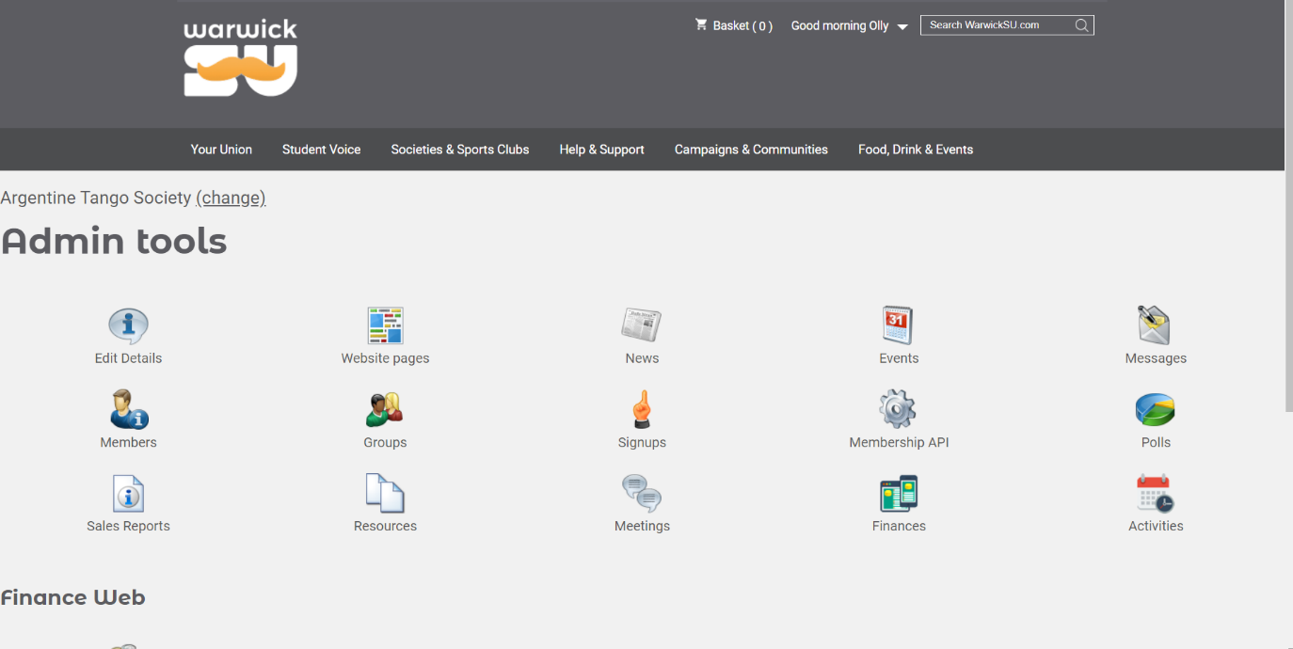
You should see the admin tools as below. If you only see Finance Web, you do not have exec permissions on your account – email studentactivities@warwicksu.com to request permissions for your president, who can then follow the guide found here to grant you permissions. https://www.warwicksu.com/pageassets/societies-sports/committee-resources/responsibilities/society-exec-training/Adding-newly-elected-exec-members-to-the-SU-website.pdf
Click on “Events”

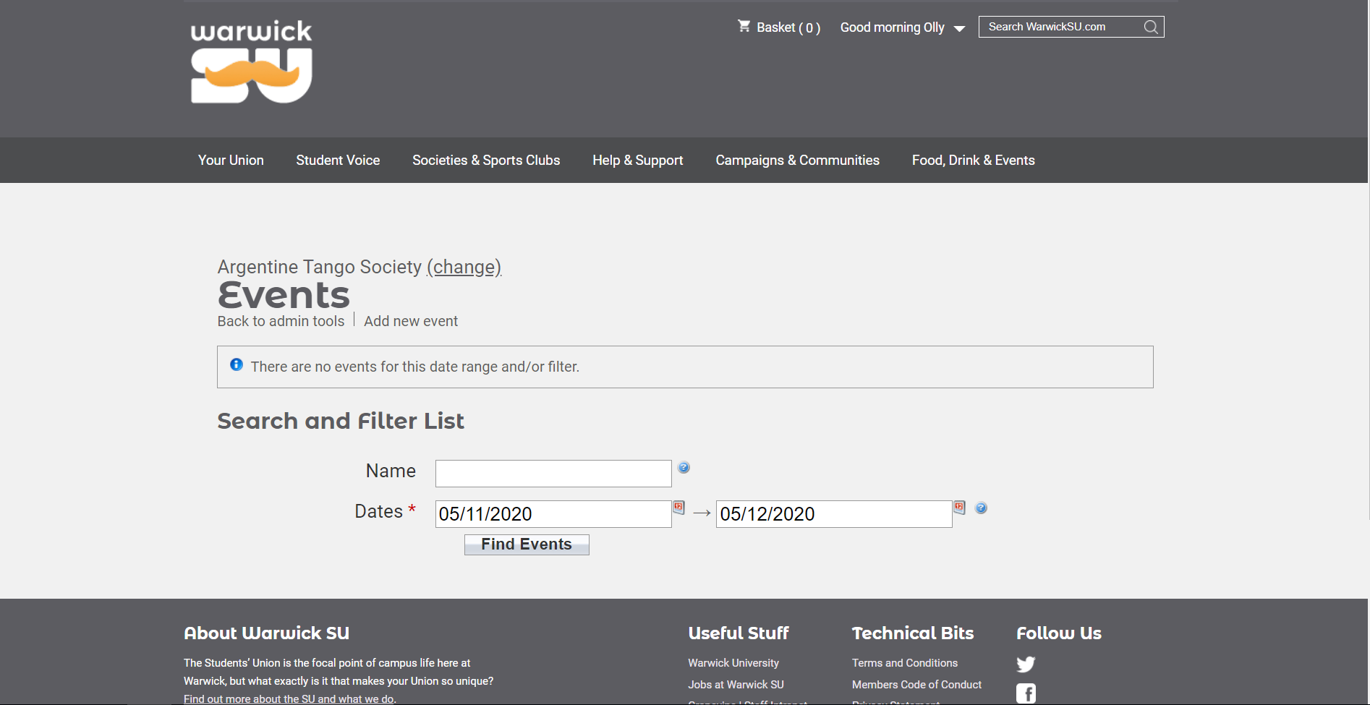
Fill in the form and Save – you are done! I’ll explain the form below if you need any more assistance!
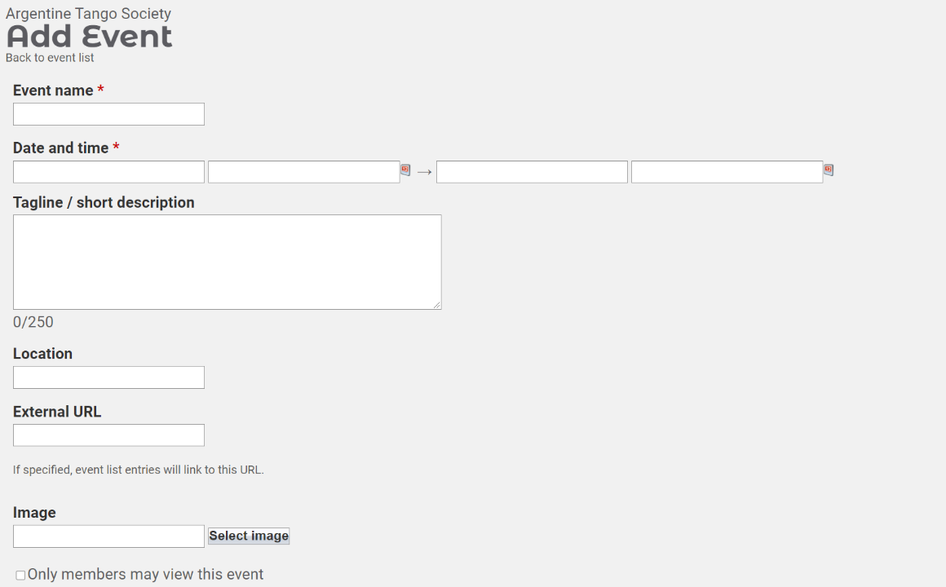
Name the event! May be a good idea to put your Society name here too!

Image is a very important part, it makes your event stand out on the page!
250 character short description that will be shown underneath the event image on the main events page.
These are the start and end times of the event – use the 24h clock as such: 16:30, 18:15, 09:00
These ones are the dates in format DD/MM/YYYY
In the full description box, make sure to describe what will go on in your event, any important info that people need to know before coming and if your event is online, make sure to put how to access the event, with contact details for any issues joining!

