Adding & removing newly elected exec members on the SU Website

This guide will take you through the process of removing old exec from the website and system, and adding the newly elected exec.

Ordinarily, the old exec would need to do this as only they would have permissions on the SU website to make alterations.

But if they have now left and not done this for your Club/Society, please let us know and we will add the NEW PRESIDENT.

That exec will then have permissions to make changes to the exec online, and can update the remaining exec.

Why is it important to update the exec online?

The exec needs to be updated online for a variety of reasons:

- The finance reimbursement system (SGF) is linked to this. So, it will only allow execs who are registered on the SU website to apply for reimbursements.
- HEAR records are also linked to this. Every year we send exec data to the University to update your HEAR report. If your exec position is not on the SU website or not accurate, your HEAR report will be affected and we can’t make changes to it.
- We need to know who you are. If you’re working with us, logically you’d need to register yourself as an exec so we can formally recognise you for a variety of activities throughout the year.

When do we need to update the SU website?

Ideally as soon as the new exec have been elected.
However, every year on 31st August, the system resets in line with the University calendar. That means all memberships are wiped. You will then have to repurchase membership for the new academic year and update the SU website one more time, once your exec have purchased membership.

Who qualify as an Exec?

You can add as many exec positions as you like.

However, only those who were voted in democratically will be formally recognised as an exec. All other positions which are not democratically elected are technically not exec positions.

Step 1:
Log into the SU website, select the drop-down menu, and find your Society/Club under where it says ‘organisations’ and click
on it.

Step 2:
It will then take you to the admin tools, select the tool labelled ‘groups’.
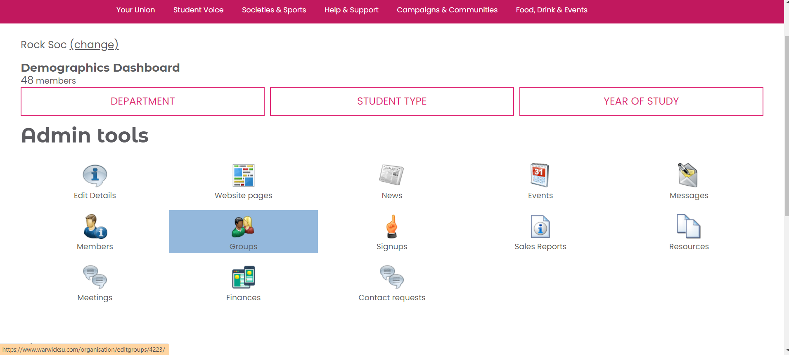

Step 3:
Then it should take you to a list of exec roles and other active groups. Select the title of the role you are wishing to change.
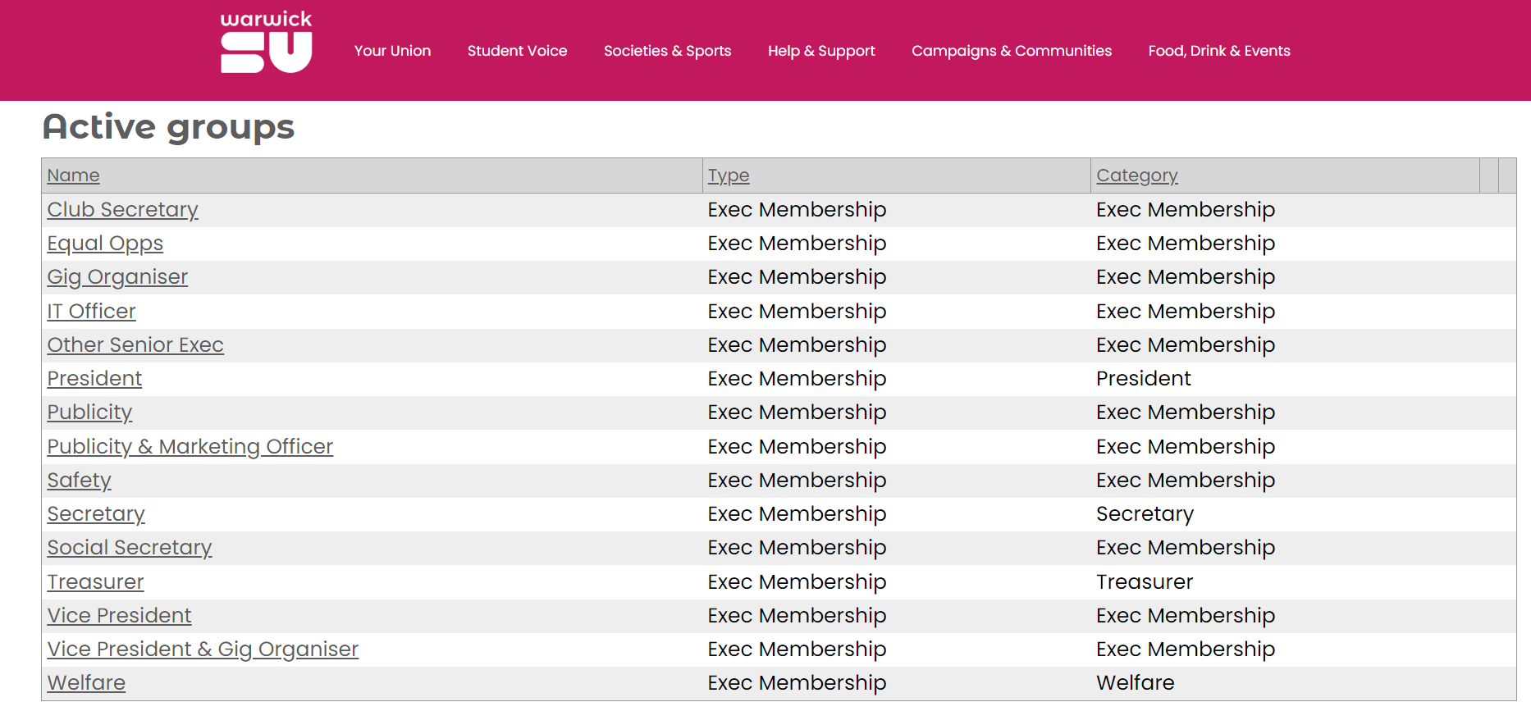

Step 4:
You will then be shown the current person in the role, and a list of all the members of the club you could select to fill this role. Press the ‘remove members’ button to remove the outgoing person from the role. (names blanked out for data protection).
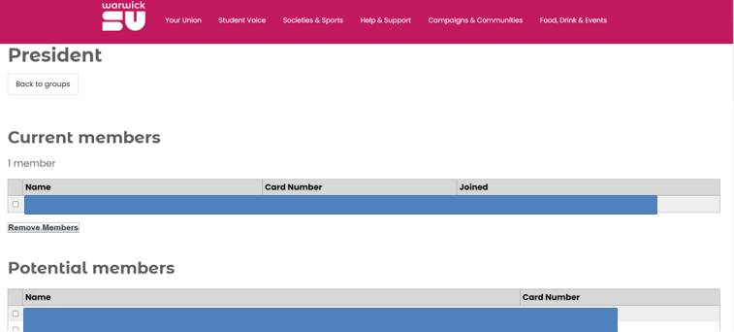

Step 5:
Select the person who is now filling the role but ticking the white box next to their name and then confirm this by clicking the ‘add members’ button at the bottom, and you should see their name at the top under ‘current members’ now. And just repeat the process for each of your roles until they are all changed over.
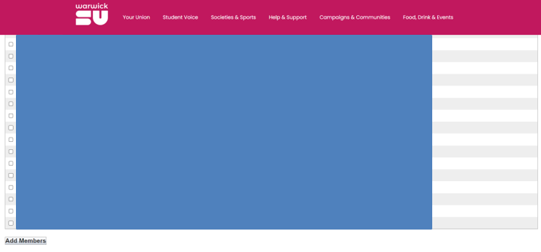

Step 6 (If applicable):
If your Society/Club has created an additional role on your exec this year, ensure that it is on your handover pack and email studentactivities@warwicksu.com to request that the role be added on. Once it has been created, you will be required to allocate the role to the appropriate member/s.
